**Java-University project 01/11 4ο**

|  |
| --- |
| Student |
| * name:String * id:String |
| * printInfo() |

s1 ` c1

Student

|  |
| --- |
| Course |
| * title:String * credits:int   Student |
| * printInfo() |

Python

5

PrintDetails()

Οι δομες δεδομενων στην ξαωα ειναι γρηγορες και αποδοτικες

Arraylist: ειναι μερος της ιδιας εγκαταστασης

Main

public class Main {

public static void main(String[] args) {

// **TODO** Auto-generated method stub

Student s1 = new Student ("Babis","ics22038");

Student s2 = new Student ("Soula","iis21047");

Course c1 = new Course("Python",5);

c1.enrollStudent(s1);

c1.enrollStudent(s2);

c1.printDetails();

}

}

Student

public class Student {

//ιδιότητες

private String name;

private String id;

public Student(String name, String id) {

this.name = name;

this.id = id;

}

public void printInfo() {

System.***out***.println("My name is: "+ name);

System.***out***.println("My id is: "+id);

}

}

Course.1(enrolledStudent)

public class Course {

private String title;

private int credits;

//αναφορα τυπου student

//εγγεγραμενοσ πινακας

private Student[] enrolledStudent = new Student [10];

//μετριτής φοιτητών

private int numberofStudents = 0;

//right click on the code+source+Generate Constructor using Fields and if there is tick on the first line it must be deleted

public Course(String title, int credits) {

this.title = title;

this.credits = credits;

}

public void enrollStudent(Student aStudent) {

enrolledStudent [numberofStudents] = aStudent;

numberofStudents++;

}

public void printDetails() {

System.***out***.println("Course: "+ title);

System.***out***.println("Credits: "+credits+" ECTS");

System.***out***.println("Has the following student: ");

//διατρέχω τον πίνακα

for(int i=0;i<numberofStudents;i++) {

//αναφορά προς ένα φοιτητή

enrolledStudent[i].printInfo();;

}

}

}

Course.2(ArrayList)

Μεθοδος size() μου επιστρεφει το πληθος των στοιχειων που μου παρεχει ο πινακας που εβαλε ο χρηστης

import java.util.ArrayList;

public class Course {

private String title;

private int credits;

//αναφορα τυπου student

//εγγεγραμενοσ πινακας

/* ctrl+shift+o

* Αν ο το ArrayList κοκκινιζει

*/

private ArrayList enrolledStudent = new ArrayList();

//μετριτής φοιτητών

private int numberofStudents = 0;

/*right click on the code+source+Generate Constructor using Fields and

* if there is tick on the first line it must be deleted

*/

public Course(String title, int credits) {

this.title = title;

this.credits = credits;

}

public void enrollStudent(Student aStudent) {

//add είναι από τις πολλές μεθόδους που κουβαλαει την ArrayList

//δομη δεδομενων το enrolledStudent

enrolledStudent.add(aStudent);

}

public void printDetails() {

System.out.println("Course: "+ title);

System.out.println("Credits: "+credits+" ECTS");

System.out.println("Has the following student: ");

//διατρέχω τον πίνακα

for(int i=0;i<enrolledStudent.size();i++) {

//Η get επιστρέφει "οτιδιποτε"

Student s = (Student) enrolledStudent.get(i);

s.printInfo();

}

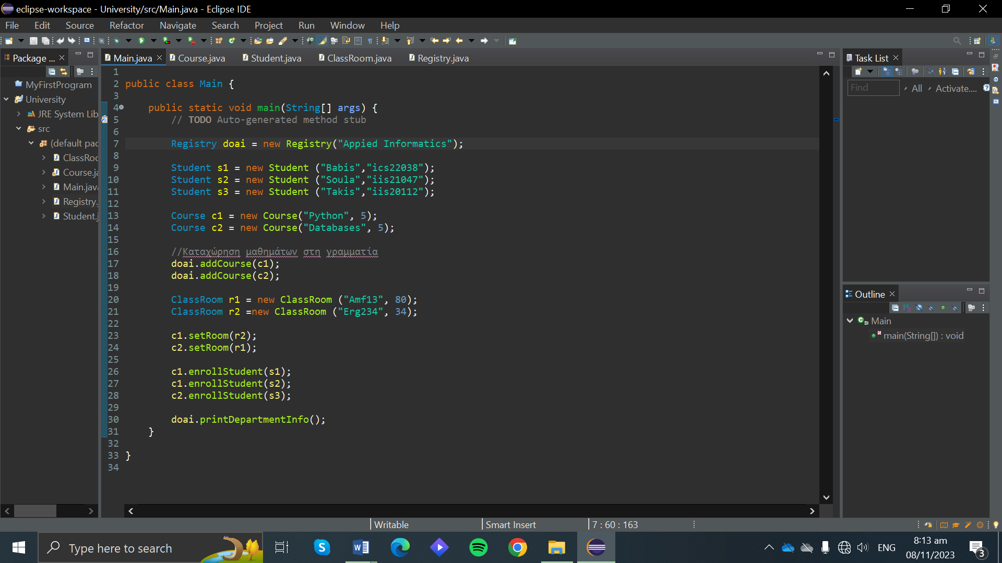 }

}

Main.3

Course.3

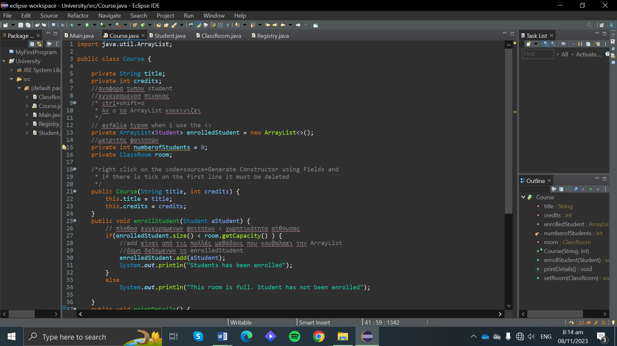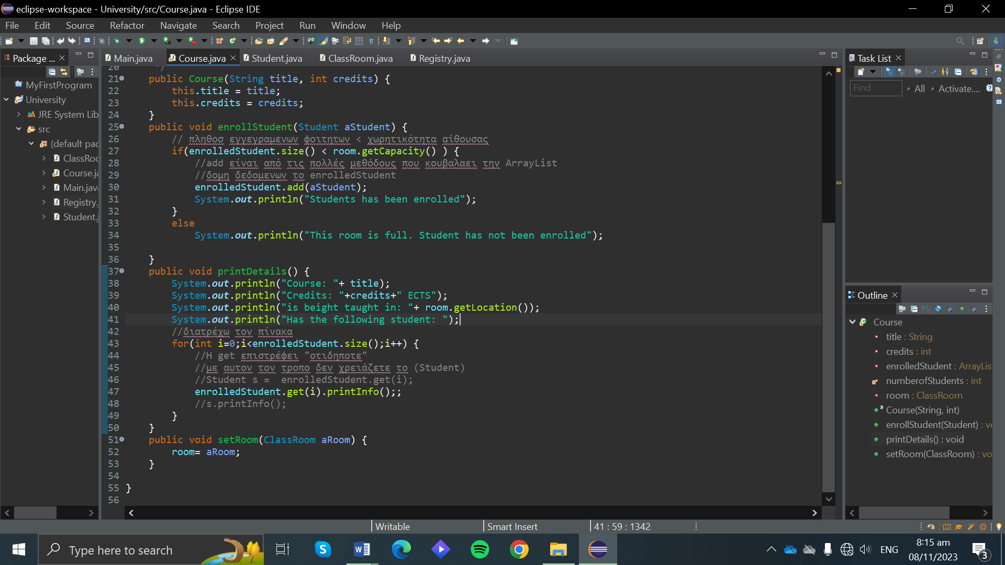

Student.3

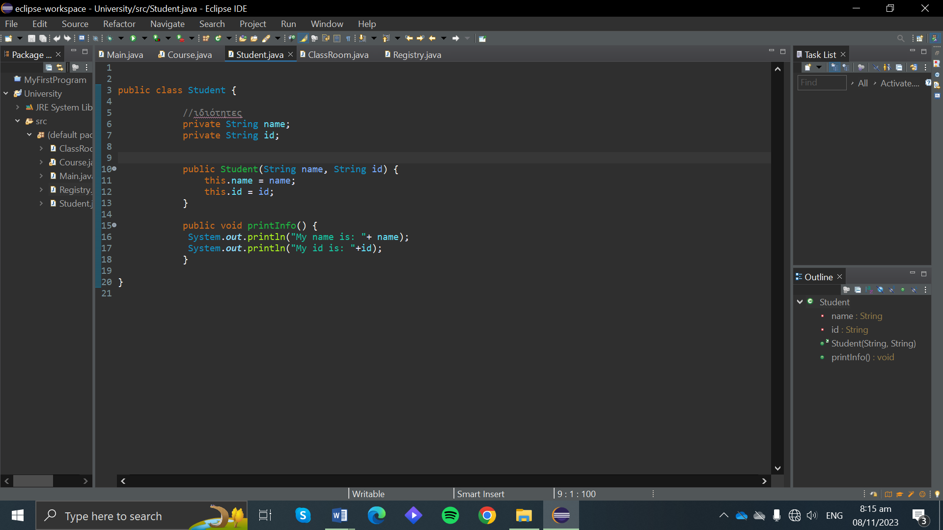

ClassROOM

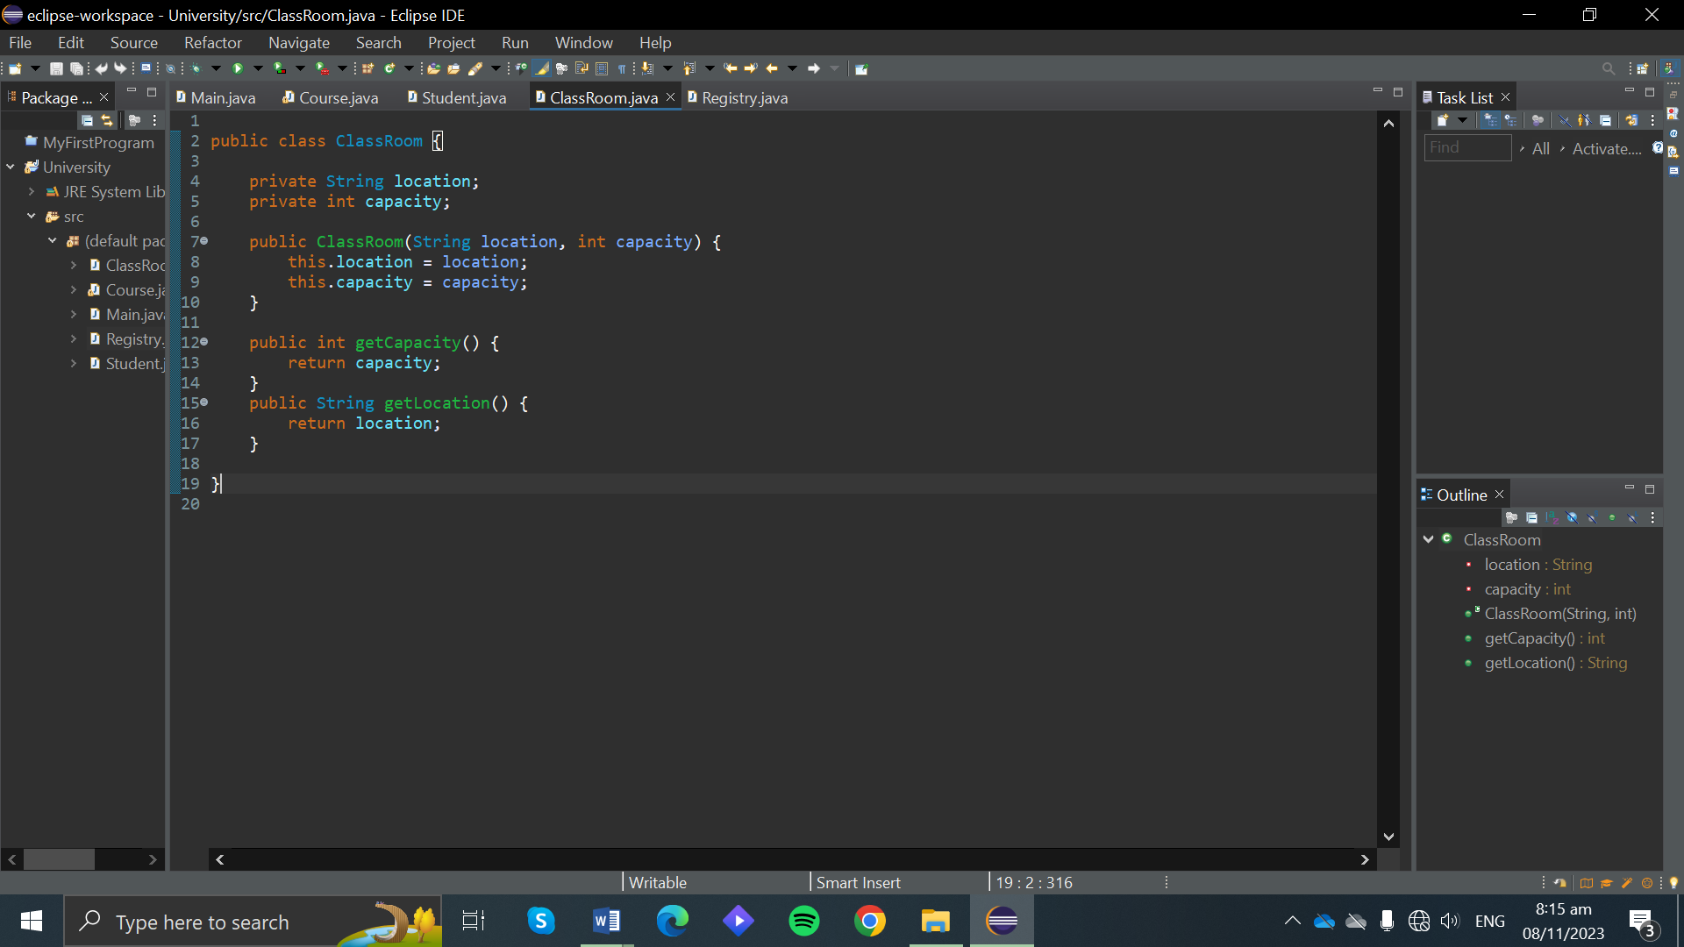

Registry

